[WiGLE](https://wigle.net/" \t "_blank) has been around a *while* and is a great site to explore the pervasiveness or sparsity of Wi-Fi (and cellular) networks around the globe. While interactive use is fun, WiGLE also has a free API (so long as you obey the EULA and aren’t abusive) that lets you explore a little deeper if you register for an account, get a key, and use the WIP [wiglr[](https://github.com/hrbrmstr/wiglr)](https://github.com/hrbrmstr/wiglr) | [GL](https://gitlab.com/hrbrmstr/wiglr)| [GH](https://github.com/hrbrmstr/wiglr) package.

Install from your least offensive social coding site:

devtools::install\_git("<https://sr.ht.com/~hrbrmstr/wiglr>")

# or

devtools::install\_gitlab("hrbrmstr/wiglr")

# or (if you must)

devtools::install\_github("hrbrmstr/wiglr")

read the code (to ensure R package developers are pwning or tracking you),and …after putting your “Encoded for use” token in the WIGLE\_API\_KEY environment variable…start exploring!

Let’s pull all the country stats and plot the top 20:

library(wiglr)

library(hrbrthemes)

library(tidyverse) # for show

cc <- wigle\_country\_stats()

top\_n(cc, 20) %>% # show top 20

mutate(country = factor(country, levels = rev(country))) %>%

ggplot(aes(count, country)) +

geom\_segment(aes(xend=0, yend=country), size = 6, color = ft\_cols$blue) +

scale\_x\_comma(position = "top") +

labs(

x = "# Networks", y = NULL,

title = "WiGLE Top 20 Countries"

) +

theme\_ipsum\_rc(grid = "X")

[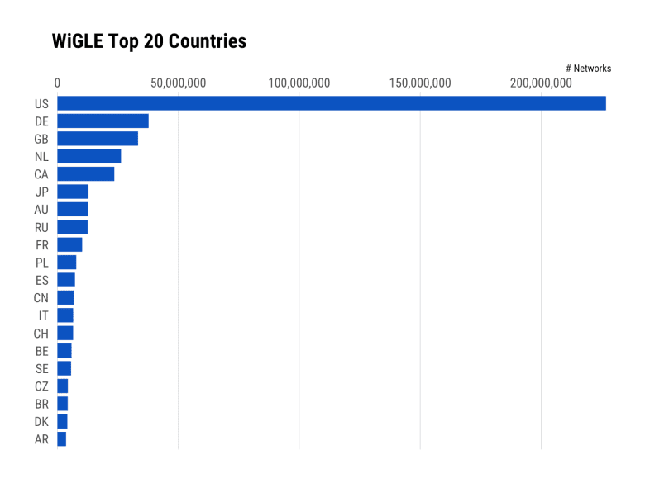](https://rud.is/b/2019/02/18/in-dev-wigle-your-way-into-a-hotspot-with-wiglr/country-stats-02-1/)

We can also supply a bounding box and find all the Wi-Fi access points in the vicinity and use leaflet to make a handy interactive map (you can add other columns, too, to find fully open ones):

library(leaflet)

wifi\_box <- wigle\_bbox\_search(43.2468, 43.2806, -70.9282, -70.8025)

wifi\_box$results %>%

mutate(labs = sprintf("SSID: %s  
Encryption: %s", ssid, encryption)) %>%

leaflet() %>%

addTiles() %>%

addCircleMarkers(~trilong, ~trilat, radius = 1, popup = ~labs)

There’s good but not complete WiGLE API coverage:

* wigle\_about\_me: Get WiGLE user object for the current logged-in user
* wigle\_api\_key: Get or set WIGLE\_API\_KEY value
* wigle\_bbox\_search: Get WiGLE named map of general statistics
* wigle\_country\_stats: Get WiGLE statistics organized by country
* wigle\_region\_stats: Get WiGLE statistics for a specified country, organized by region
* wigle\_site\_stats: Get WiGLE named map of general statistics

**FIN**

The package is a WIP but the API is really straightforward, so if you’re looking to contribute to a (dare I say “fun!”) open source project in 2019 now’s your chance! Just drop an issue on whatever social coding site you prefer (ping me in a comment if you use something besides SourceHut, GitLab or GitHub and I’ll get the package up there) and spec out what you’d like to do *or* just file a well-articulated PR. Potential areas to enhance are:

* support for more search parameters
* a function for automatic pagination
* cover the remaining search/retrieval API endpoints
* investigate how to use R to *submit* readings
* create an internal package Shiny app for exploring WiGLE straight from R
* develop standard base visualizations and add them as package functions
* write a vignette
* improve package docs
* develop a statistical model for the likelihood on finding free/open Wi-Fi in an area or the impact of Wi-Fi/cellular deserts on communities by layering in Census data

Working with or developing for the package may also help shed some light on yet-another-way we’re exposed in the digital world.

As always you’ll get judgement-free help/suggestions. full credit in the DESCRIPTION and the fame and glory of CRAN if it ever makes its way through the process. The package does *just enough* for me right now so it will be a while before I get to the above TODO list if others don’t jump in first.